Volunteer Registration Form 2018

Your Details
Name:
Telephone:
Email:
Address:

Post Code:

Emergency Contact Details
Please provide details of someone we can contact in the event of an emergency
Name:
Telephone:
Email:
Address:

Post Code:
Relationship to you:

Please tick this box if you are under 25 years of age
Please tick this box if you consider yourself to be part of the Black, Minority or Ethnic (BME) community
Volunteer role you are applying for (see our website for available roles):

Your Availability
Please specify your availability in as much detail as possible
Start Date: |  |  |  |  | End Date (if known):
Day/s | Mondays | Tuesdays | Wednesdays | Thursdays |  | Fridays | Saturdays | Sundays
Time/s

Any medical condition or other information you think we need to know about to support you in your volunteer role:

Further Info (Optional)
Please help us meet your expectations, by providing us with more information in the boxes below
Skills  List any skills relevant to volunteer job role you are applying for | Education  List any relevant education or training qualifications you hold
Goals  Tell us about your short term and long term goals so we can help you achieve them during this post | Employment  What would be your dream job? What would be a realistic job? Let us know about your ambitions

Volunteer Declaration
By signing up to volunteer for Trinity Community Arts (TCA) you agree to adhere to TCA's Code of Conduct and treat other volunteers, staff and visitors with respect at all times. You agree to work reliably and to the best of your ability and to give as much warning as possible whenever your are unable to attend. You are expected to follow TCA’s rules, policies and procedures, including our health and safety and equal opportunities policies. Your agree for your personal details to be stored on TCA's volunteer database, which may be shared with legitimate organisations as part of your volunteer role for monitoring and evaluation purposes only.

TCA is committed to supporting volunteers and will apply policies that support you in your role. These include our health and safety, equal opportunities and complaints and grievances policies. We will work with you to identify your goals and ambitions, to ensure that you are able to develop within your role and have a positive volunteering experience. TCA will provide you with a safe workplace and take appropriate steps to insure you against personal accident or injury in your volunteer work role. TCA will not share your details with third parties unconnected to this volunteer process.

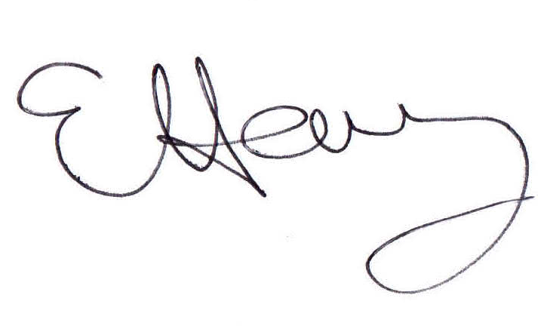
Please note: this is an honour agreement only and is not intended to be a legally binding contract of employment.

Emma Harvey, Centre Manager, Trinity Community Arts

